Barack Obama accuses NRA of misleading US over guns
http://www.bbc.com/news/world-us-canada-35259578
US President Barack Obama has strongly criticized the most powerful US gun lobby during a televised public forum.
He said the National Rifle Association (NRA) had deliberately misrepresented proposed legislation on gun control. The NRA declined to take part in the discussion, which it called a public relations spectacle. Meanwhile, US Republican presidential hopeful Donald Trump said he would eliminate gun-free zones in schools on his first day in office, if elected. Addressing the audience at George Mason University in Fairfax, Virginia, Mr Obama blamed the NRA and others for suggesting that "somebody's going to come grab your guns". He said that all he was seeking to do was strengthen background checks - not seize all firearms.

He took questions from Taya Kyle, whose late husband, shooting victim Chris Kyle, was depicted in the film American Sniper.
Separately, in an article in the New York Times, he called gun violence a national crisis, and urged owners and firearm manufacturers to play their part in ending it.
Mr Obama added that he would not campaign for Democrats who did not back gun reforms, saying he wanted leaders brave enough to stand up to what he called the gun lobby's lies.
NRA spokesman Andrew Arulanandam said the group had seen "no reason to participate in a public relations spectacle orchestrated by the White House".

What is the NRA?
History: The NRA was founded in 1871 with the aim of training men in marksmanship. It began lobbying on gun policy in 1975 and is now one of the most powerful special interest groups in the US.
Budget: The NRA has big coffers. It spends about $250m per year - more than all of America's gun control advocacy groups combined. About $3m of that is spent on lobbying.
Membership: The association boasts of nearly 5m members, although analysts say the figure is probably closer to 3m. Famous members have included Charlton Heston, Whoopi Goldberg, and former president George Bush Snr.
Controversy: The NRA has been widely criticized for its statements on mass shootings, including a claim in the wake of the Sandy Hook massacre that a lack of armed guards at schools was to blame.

Donald Trump made his promise to end gun-free zones when he addressed a rally in Vermont.
"You know what a gun-free zone is for a sicko?" he asked the crowd. "That's bait."
Earlier this week, Mr Obama unveiled a package of executive actions aimed at keeping guns from people who should not have access to them.
These involve
- Background checks for all gun sellers, overturning current exemptions to some online and gun show sellers
- States providing information on people disqualified from buying guns due to mental illness or domestic violence
- Increased workforce for the FBI to process background checks, hiring more than 230 new examiners
- Congress being asked to invest $500m (£339m) to improve access to mental healthcare in the US
- The departments of defense, justice and homeland security exploring "smart gun technology" to improve gun safety
Leading US Republicans denounced the move.
House of Representatives Speaker Paul Ryan said the executive orders, which bypass Congress, "undermined liberty" and would be challenged in court.
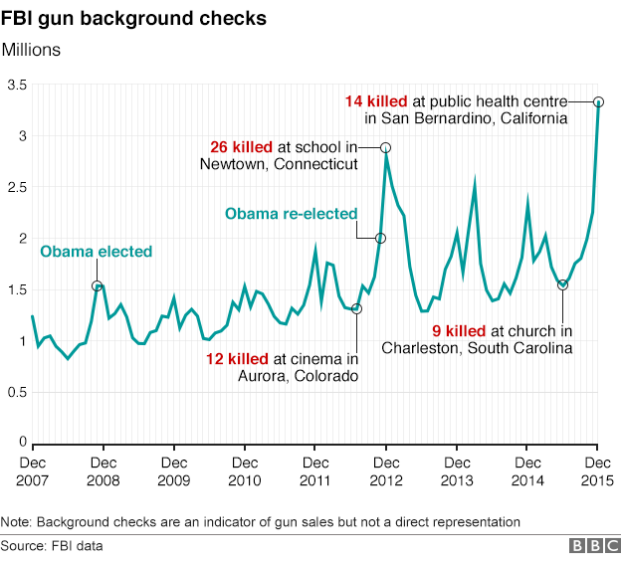

Answer in Complete Sentences!
1. Based on this graph. How much have background checks increased since 2007?____________________
______________________________
______________________________
2. Were there more background checks during Obama’s first or second term?__________________
3. Contrast Obama’s gun policy views to Donald Trump.
_____________________________________________________________________________________
4. Which executive action do you think would be most effective in making a difference in gun violence?
____________________________________________________________________________________
____________________________________________________________________________________
5. Which executive action do you think is not worth the cost and would be least effective?
_____________________________________________________________________________________
_____________________________________________________________________________________

