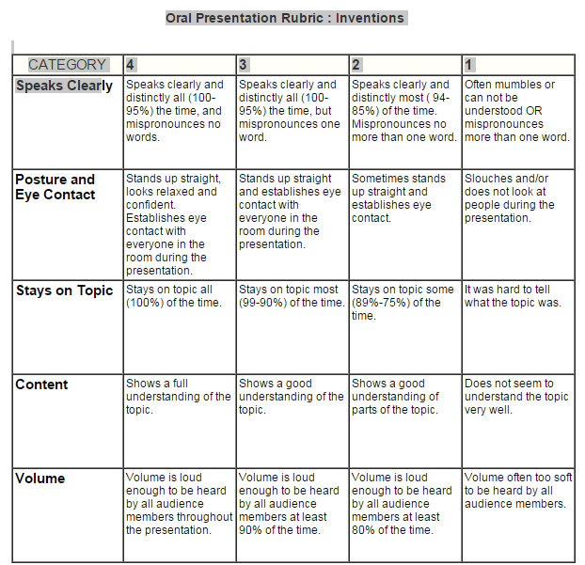
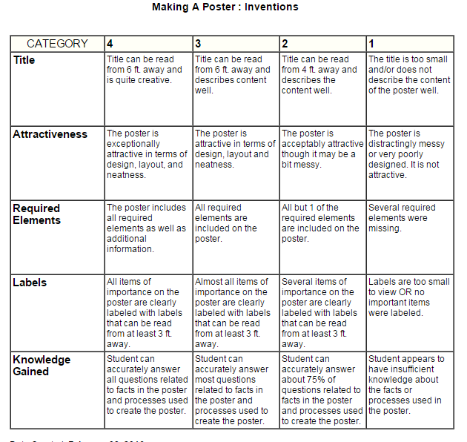
Black History Month Project: African American Innovators and Inventors due by February 18th.
Your project must focus on ONE African American innovator or inventor. They can be from any time period of history including modern day. No celebrities or athletes need apply! You must sign up and have your selection approved by Ms. Kasper. Your presentation should be between 1-2 minutes, have poster containing the key information, and must include:
Key biographical information, their innovation/invention and its importance to history, what obstacles/failures did they face, how were they significant in their time period, what motivated them, why should this person be admired.

