Multiple Choice

- The Fundamental Orders of Connecticut was

- Which is an example of an early attempt to establish laws that promoted the common good?

- In most colonies decisions were made by

- The English Bill of Rights was important to colonists because it

- The Mayflower Compact, the Fundamental Orders, and town meetings all showed the determination of
colonists to

- How did William Penn preserve and protect the rights of citizens in the colony he founded?

- ________ is the acceptance of different beliefs.

- Puritan life was centered around:

- Which best describes why shipbuilding became important in the New England colonies?

- In return for the payment of their passage to the Americas, these colonists agreed to work without pay for four to seven years. They were called:

- The following would be a geographic feature of the southern region:

- The people who settled in the Middle Colonies represented…

- Tobacco and sugar cane are examples of
- What feature made the Southern Colonies unique?

- How did the warm climate and long growing season impact choices about how human resources were developed in the Southern colonies?

- A large percentage of Blacks who lived in colonial America in 1750 were enslaved. Which statement is true about the colonies?

- Compared to today’s cities, colonial cities were very

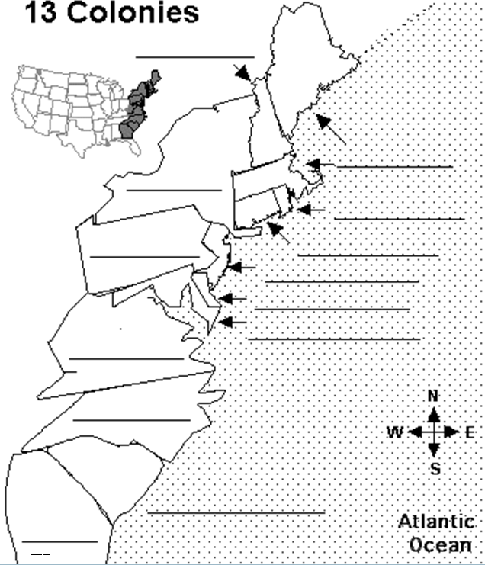
Matching:
- This was the first form of self-government in the colonies
- People who wanted to purify the Anglican Church.
- First form of a constitution written in America
- Their journey to America on the Mayflower was made for religious freedom
- A settlement made by people who leave their own country to settle in another land, but still remain citizens of their original country

23-28 You will be given descriptions of 3 colonies and you will need to identify which colony they are and why they were founded!

29-35 You will need to identify colonies on the map.

