1. The ocean between the Americas and Europe



1. According to the theory on which this map is based, from which continent did hunters migrate to North America?
2. According to this map, what geographic feature allowed hunters to migrate into North America?
3. This region relies on farming because their land is very fertile and they have a long growing season. They are mound builders and use deerskin to cloth themselves.
4. This region builds adobe houses that hold thousands of people called pueblos
5. This region has cold winters and is between the coast and thick forests. Their housing would be?
6. Sun baked clay bricks used to build thick-walled houses



1. Using the graphic**,** which of the following plants originated in the Americas?
2. What does this excerpt from Columbus’s diary tell us about his plans for the native people?

*“It appears to me, that the people are ingenious, and would be good servants and I am of opinion that they would very readily become Christians, as they appear to have no religion.”*

Christopher Columbus

1. This West African kingdom of Ghana became rich and powerful from the trade of?
2. This religious group conquered the Holy Land which instigated (started) the Crusades.
3. After the Native Americans met the Europeans, Native American populations
4. An effect of the failure of the Crusades is
5. This time period is defined by a war between the Christians and Muslims over the Holy Land.
6. The rebirth of learning that led to advances in science, math, art, and literature.
7. Why did Europeans want to explore?
8. A reason that the Native Americans and Europeans conflicted was the belief
9. Which of these was an effect of the movement of goods and people between Africa, North America, and England?
10. Which of these was an immediate effect of European contact with Native American cultures?
11. One element of culture that described most Native American cultures was the belief
12. The Spanish used captive Africans as
13. Mercantilists would advocate that a nation do which of the following?
14. What two factors first led Europeans to begin to explore westward?
15. What was an effect of the Columbian Exchange?
16. What is one way in which the Great Convergence led to an exchange between cultures?
17. What was one result of the Columbian Exchange?
18. Which plants originated in the Americas?
19. What is one way in which the Great Convergence led to an exchange between cultures?
20. What was one negative outcome of the Great Convergence?
21. What was one positive outcome of the Great Convergence on Europe?
22. How did the climate and geography of North America and the West Indies affect the slave trade?
23. Which is an example of an early attempt to establish laws that promoted the common good?
24. Which statement below best explains the conflict that led to the French and Indian War?
25. Why did General Gage send troops to seize
26. How did the colonists convince Parliament to
27. How did southern plantation owners address the issue of scarcity of human resources in the Southern colonies?
28. Which best describes why shipbuilding became important in the New England colonies?
29. The colonists’ reaction to the removal of King James II and the adoption of the English Bill of Rights
30. **“…give me liberty, or give me death!”**  **“A government of our own is our natural right…” “We must indeed all hang together or, most assuredly, we shall hag separately.”** During the American Revolution, members of which group made these statements?
31. One belief that most colonists shared was that
32. In the Declaration of Independence, the founders argued that the fundamental purpose of government is to
33. What popular method of colonial protest tried to damage the British economy in order to influence Parliament to repeal taxes?
34. Why did the Southern Colonies have large populations of enslaved persons?
35. A large percentage of Blacks who lived in colonial America in 1750 were enslaved. Where did slavery primarily exist?
36. Which limited natural resource led to the exploration of the Americas and caused conflict among European nations?
37. The United States has a federal system of government because
38. Which statement best illustrates the principle of federalism?
39. The legislative branch is responsible for making laws, the executive branch for enforcing them, and the judicial branch for making sure all laws are Constitutional. This is an example of
40. The United States Constitution established a government based on the basic concepts of separation of powers and checks and balances. The authors of the Constitution included these two concepts because they
41. Which statement illustrates the system of checks and balances at work?
42. Which constitutional principle do these statements represent?

• The president appoints new members to the Supreme Court.

• The Senate must approve presidential appointments to the Supreme Court.

• The Supreme Court can declare unconstitutional laws made by Congress.

**Use this excerpt from the Preamble to the U.S. Constitution to answer**

*We the People of the United States…do ordain and establish this Constitution.*

1. Which of the following concepts is **best** represented by the excerpt above?
2. How did Congress attempt to avoid war and still react to Great Britain’s violation of U.S. neutrality?
3. What changes to the federal government were brought about by Henry Clay’s American System?
4. Why did Thomas Jefferson believe that the Constitution should be interpreted strictly?
5. Which belief of the states’ rights doctrine challenged the concept of federalism?
6. In the 1820s the newly independent Mexican government worked to attract settlers to Texas. What caused these settlers to eventually declare independence from Mexico?
7. During the 1840s thousands of people were attracted to California to?
8. According to this map, what was the most difficult geographic feature that Lewis and Clark had to cross?

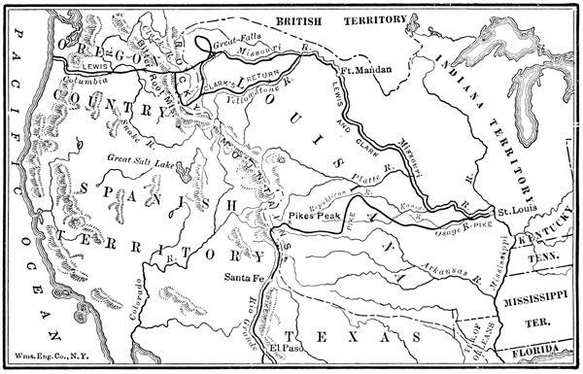

1. The primary reason Thomas Jefferson asked Lewis and Clark to explore the West was to:
2. *“ The Cherokee are nearly all prisoners. They have been dragged from their homes and encamped at the forts and military places, all over the nation…. The property of many has been taken and sold before their eyes for almost nothing.”*

This quotation for an eyewitness on the Trail of Tears describes the events connected with the

1. Sectionalism in the United States contributed most to the start of the
2. How did the invention of the cotton gin affect choices made about the use of human resources?
3. What was one way that people used railways to solve the problem of limited natural resources?
4. Why did a majority of immigrants to the United States decide to settle in the Northeast?
5. Which best describes the economic system that developed in the United States around cotton?
6. How did the introduction of steam power affect manufacturing in the United States?

1. How did interchangeable parts make the machines used in manufacturing more efficient?
2. An advantage of the railroads and canals in the North and Midwest was that
3. What geographic advantage in the South slowed the development of manufacturing?
4. How did steam power create a trade advantage for new factories?
5. Which concept is most clearly illustrated by the election results shown on this map?



1. The Underground Railroad was developed in the 1840s in order to
2. The Compromise of 1850 allowed California to be added as a free state, and designated the territories of New Mexico and Utah open to slavery. The compromise also ended the slave trade in Washington, DC, and called for the passage a strong fugitive slave law. Henry Clay from Kentucky proposed this compromise to

**Use the graphic below to answer the next TWO questions** 

1. At the beginning of the Civil War, the South had an advantage over the North in
2. Which conclusion about the Civil War is most clearly supported by information in the chart?

**Use the graphic to answer question**



1. Which conclusion can best be supported by the information in this illustration?
2. The agricultural nature of the early Southern colonies led to an economic system that relied on
3. How did the idea of popular sovereignty cause conflict in the Kansas and Nebraska territories?
4. In his ruling on the case of *Dred Scott v. Sandford*, Chief Justice Roger B. Taney ruled that