Trump's Tax Plan: The Good, The Bad And The Ugly
John T. Harvey , CONTRIBUTORI want to explain how things work, not what you should believe. Opinions expressed by Forbes Contributors are their own.
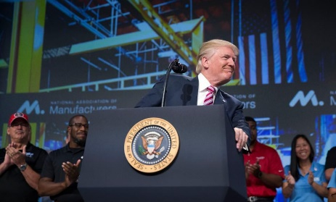
WASHINGTON, DC - SEPTEMBER 29: (AFP OUT) U.S. President Donald Trump delivers remarks on tax reform to the National Association of Manufacturers at the Mandarin Oriental Hotel September 29, 2017 in Washington, DC. (Photo by Shawn Thew-Pool/Getty Images)
President Trump is in the process of attempting to get yet another of his programs put in place. This time it is his tax plan (detailed here: Unified Framework for Fixing Our Broken Tax Code). He and his supporters believe that what he has laid out will both strengthen the middle class and reinvigorate business. I will examine these claims.
To start, the President is quite right that we have problems that need to be addressed and that they could be at least partially ameliorated by changing the tax system. Two of the most pressing are the current distribution of income and the continued weak demand for labor. With respect to the former, the shift from the poor and middle class to the rich has been so well documented that both parties’ campaigns acknowledged it and promised to address it. A capitalist economy runs from the bottom up, from consumer to producer, and this is a critical area to address. In terms of the second, yes, unemployment is down, a process that began in earnest during the Obama administration. But U-6, the broader measure that includes marginally-attached workers and people who are doing part-time work but would prefer full-time, remains at 8.6%. Again, this is something that has become so widely accepted that both parties treated it as a fact in evidence during the campaign. And not only do we want unemployment of every variety to be lower, but this would also help to address the income-distribution problem.
Each item of the tax reform will therefore be evaluated in terms of the likelihood that it may 1) help the middle class to recover or 2) increase the demand for labor (which should not only reduce unemployment but also raise wages and therefore help with #1). Within this context and acknowledging the fact that many details remain unsettled, the tax plan has some good, some bad, and some ugly.
The Good
These may help.
• Increased Deductions and Tax Credits for Children, New Tax Credit for Non-Child Dependents: Anything that reduces the tax burden has the potential to increase demand–not as effectively as an increase in government spending, but nevertheless (see 'The Ugly' for more on this). The biggest caveat here is that one must already have a decent job for it to be very helpful. A single mother working at a minimum-wage or part-time job won’t have much of a tax burden to start with. Hence, though it may help those in the middle class, it does little to move one into that category from below.
• Consolidation of Tax Brackets, Simpler Overall System: Assuming the progressivity remains (and this has been promised), which helps address the income distribution issue, simpler can’t be a bad thing. The overall economic impact may be close to nil, but there will be fewer short tempers around tax time. Maybe lowering blood pressure raises GDP?
• Revised Tax Rate Structure for Small Business: Let me open here with a warning: generally speaking, tax cuts don’t cause businesses to hire more workers (I will return to this below). If your restaurant is half empty, you need customers. Of course you would welcome the tax cut and this may help to at least temporarily preserve the jobs of those servers and cooks currently at your establishment. Nothing, however, is going to cause you to increase employment until you find that you cannot meet demand with current staff. Then, even if taxes aren’t cut, you’ll start hiring. All that said, however, small businesses are the first ones to suffer in a downturn and they are the ones that generate the most new employment is in the upturn. Plus —and this is admittedly entirely a personal bias — these are often among the hardest-working people in the economy. When you start a family restaurant, you can forget vacations and weekends off for the foreseeable future. You are there before opening and after closing and every problem is your problem. A tax cut helps them and I think that’s a positive. (I have a real soft spot for these people, as I do for other group that falls into the hardest-working category: low-wage workers.)
• Elimination of State Income Tax Deduction: I’m going to include this here because, while this is clearly a negative when compared to the first item above, early reports suggest that its biggest impact will be on a wealthy minority (White House: State and local tax deduction will be gone, but this is not a 'red line'). This clearly helps with the income distribution issue. The justification for it, however, is rather frightening (i.e., that it will help offset the other tax cuts; see 'The Ugly').
The Bad
These might be neutral or even make things marginally worse.
• Cut in Corporate Tax Rates: The theory here is that it would stimulate economic activity and employment. But, as argued above, firms don’t change hiring as a result of changes in the tax burden. And, while I stood in favor of this with respect to small business, for corporations this has the potential to further consolidate their power (Corporate concentration). A capitalist economy grows from the bottom up, not top down, because the former is the core of demand for goods and services. Adam Smith was about competition, not concentration.
• Elimination of Estate Tax, Tax Cuts for the Wealthy: This will affect exceedingly few individuals, but it is clearly counter to the goal of returning us to a distribution of income where money is in the hands of those who spend rather than save. There is at least currently a promise to maintain at least the current degree of progressivity to the tax system. We shall see. If not, this needs to be shifted under 'The Ugly'.
• Reduced Taxes on Repatriated Funds: The rationale for this move is to encourage multinationals to bring money back to the U.S. and invest it here rather than abroad. The problem is that Ford doesn’t have plants in Chihuahua, Cuautitlan, and Hermosillo because taxes are lower in Mexico than they are in Michigan, it’s because labor is cheaper: “U.S. autoworkers made, on average, just under $30 per hour compared with just more than $5 per hour in (Mexico) 2014, according to Kristin Dziczek, director of the labor and industry group at the Center for Automotive Research in Ann Arbor” (6 reasons Ford picked Mexico for a new plant). I can’t even begin to imagine the tax break necessary to even that playing field. If multinationals bring money back home, it won’t be to invest in physical capacity or employment.
The Ugly
This one is disastrous.
• Fiscal "Responsibility:"To be fair, this remains completely unresolved and President Trump has, at least on occasion, been on the right side of this issue. But, conversations are already taking place on both sides of the aisle about how these cuts will be offset by reduced spending. Then what the hell is the point? This trumps (if you will) everything that is on the unfortunately small list of what is potentially useful about tax reform. The math here is very simple. Let’s say you have a renter who also serves as a custodian at your property. Further say that you pay her $2000/month for her custodial work and you charge $1400/month rent. “I have good news!” you tell her, “I’m cutting your rent to $1200/month!” Hooray! “Oh, and to pay for this I’ll be reducing your pay to $1800.” Hooray? For some strange reason, while people clearly understand that taxes affect our income, they don’t realize that government spending does, too. It’s like that money goes into a hole somewhere and a reduction in spending helps all of us...except, of course, soldiers, sailors, marines, airmen, librarians, park rangers, police, fire, DMV employees, etc., and all those in the private sector working on government projects. In fact, the problem is actually worse than I have described. Government spending is always more effective than tax cuts because while all of the former gets injected into the economy as income, at least some of the latter will be saved. The average of the latter for the U.S. is around 10%. So, a tax cut of $10 leads to $9 of spending. If we then cut government spending by $10, we’re a dollar short of where we started!!! None of this even addresses two far more critical issues: a) the government’s deficit is, by definition, our surplus (look back at the landlord example above) and b) it is impossible for the U.S. to be forced to default on any debt in dollars. Impossible (for more on these issues, see: It Is Impossible For The U.S. To Default, Four Reasons You Should Consider Washington's Deficit As Your Surplus, How Fiscal 'Responsibility' Creates Unemployment).
In summary, there are some admittedly limited positive elements of the tax plan. Most of it, however, will not accomplish what its framers hope. Indeed, they might exacerbate our current problems. My biggest fear, however, is that the mathematically-challenged individuals who call themselves fiscally responsible will get their way. In that event, we’d literally be better off if we did nothing at all.
https://www.forbes.com/sites/johntharvey/2017/09/29/trump-tax-good-bad-and-ugly/#7c2571a3303f

Energy and Environment

Trump to cut Bears Ears National Monument by 85 percent, Grand Staircase-Escalante by half, documents show
By Juliet Eilperin By Juliet Eilperin
Energy and Environment
November 30, 2017
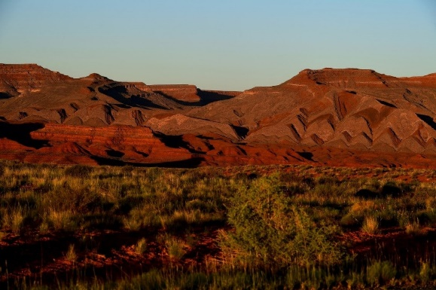
Bears Ears National Monument, near Mexican Hat, Utah. (Katherine Frey/The Washington Post)
President Trump plans to shrink Bears Ears National Monument by 85 percent and reduce Grand Staircase-Escalante National Monument nearly by half, according to documents obtained by The Washington Post that show the Utah sites would be cut even more than administration officials previously signaled.
Individuals briefed on the matter, who spoke on the condition of anonymity ahead of a formal announcement, cautioned that some changes still could be made before Trump makes his final decision public. He is slated to do that Monday in Salt Lake City.
Trump will announce the changes to monuments established by former presidents Barack Obama and Bill Clinton, respectively, at the Utah Capitol before a crowd of supporters. The move will represent the most significant reductions by any president to designations made under the 1906 Antiquities Act, which gives the president unilateral authority to protect imperiled sites on federal lands and in federal waters.
The new proclamations, which also will split up both monuments into several smaller ones, would cut the overall size of Bears Ears from 1.35 million acres to 201,397 acres and Grand Staircase-Escalante from nearly 1.9 million acres to 997,490 acres.
Many Republicans, including Trump and state and local officials in Utah, have argued that previous presidents have abused their authority under the Antiquities Act by placing large areas off limits to industrial development, motorized vehicle use and other activities. Trump signed an executive order in April instructing Interior Secretary Ryan Zinke to scrutinize any national monument larger than 100,000 acres that was established in the past 21 years. His administration, Trump said, would “end these abuses and return control to the people, the people of all of the states, the people of the United States.”
Zinke submitted a report to the White House in late August that proposed decreasing the size of at least four existing national monuments, plus changing the way a half-dozen more are managed, to allow for activities such as logging in forests where that is now off limits and commercial fishing in marine protected areas.
The Interior Department did not comment Thursday.
A coalition of conservation groups and tribes, who view Bears Ears as an important ancestral Pueblo site, are prepared to fight the changes in court. While Congress can alter national monuments easily through legislation, presidents have reduced their boundaries only on rare occasions.
Woodrow Wilson nearly halved the acreage of Mount Olympus National Monument, which Theodore Roosevelt had established six years earlier. In 1938, the U.S. attorney general wrote a formal opinion saying the Antiquities Act authorized presidents to establish a monument but did not grant them the right to abolish one. Several current legal scholars argue that Congress indicated in the Federal Land Policy and Management Act of 1976 that it reserved the right to alter any existing monument.
Kate Kelly, public lands director for the liberal think tank Center for American Progress, said in an email Thursday that the administration’s plan would amount “to the largest elimination of protected areas in U.S. history” and would affect “an area more than six times the size of the Grand Tetons.”
But many Republicans from western states welcome the idea of confining federal protections to a more limited area.
“The details of the president’s announcement are his and his alone to make, but I appreciate his willingness to listen to my advice and, even more importantly, to give the people of Utah a voice in this process,” Sen. Orrin G. Hatch (R-Utah) said in a statement. “I believe his proclamation, following Secretary Zinke’s fair, thorough, and inclusive review, will represent a balanced solution and a win for everyone on all sides of this issue.”
The draft documents do not include many specifics on how the revised monuments will be managed, but each one emphasizes that the monument designations are “confined to the smallest area compatible with the proper care and management of the objects identified” by the president as worthy of protection.
Grand Staircase-Escalante, established in 1996, would be split into three areas known as Grand Staircase National Monument, Kaiparowits National Monument and Escalante Canyons National Monument. Bears Ears, established just last year, would be divided into Indian Creek National Monument and the Shash Jaa National Monument, the latter of which will include two well-known ruins, Moon House and Doll House.
1938, the U.S. attorney general wrote a formal opinion saying the Antiquities Act authorized presidents to establish a monument but did not grant them the right to abolish one. Several current legal scholars argue that Congress indicated in the Federal Land Policy and Management Act of 1976 that it reserved the right to alter any existing monument.
Kate Kelly, public lands director for the liberal think tank Center for American Progress, said in an email Thursday that the administration’s plan would amount “to the largest elimination of protected areas in U.S. history” and would affect “an area more than six times the size of the Grand Tetons.”
But many Republicans from western states welcome the idea of confining federal protections to a more limited area.
“The details of the president’s announcement are his and his alone to make, but I appreciate his willingness to listen to my advice and, even more importantly, to give the people of Utah a voice in this process,” Sen. Orrin G. Hatch (R-Utah) said in a statement. “I believe his proclamation, following Secretary Zinke’s fair, thorough, and inclusive review, will represent a balanced solution and a win for everyone on all sides of this issue.”
A coalition of conservation groups and tribes, who view Bears Ears as an important ancestral Pueblo site, are prepared to fight the changes in court. While Congress can alter national monuments easily through legislation, presidents have reduced their boundaries only on rare occasions.
Woodrow Wilson nearly halved the acreage of Mount Olympus National Monument, which Theodore Roosevelt had established six years earlier. In

The draft documents do not include many specifics on how the revised monuments will be managed, but each one emphasizes that the monument designations are “confined to the smallest area compatible with the proper care and management of the objects identified” by the president as worthy of protection.
Grand Staircase-Escalante, established in 1996, would be split into three areas known as Grand Staircase National Monument, Kaiparowits National Monument and Escalante Canyons National Monument. Bears Ears, established just last year, would be divided into Indian Creek National Monument and the Shash Jaa National Monument, the latter of which will include two well-known ruins, Moon House and Doll House.

https://www.washingtonpost.com/news/energy-environment/wp/2017/11/30/trump-to-cut-bears-ears-national-monument-by-85-percent-grand-staircase-escalante-by-half-documents-show/?utm_term=.b263d0b2a248

Comparison chart
Democrat versus Republican comparison chart
 | Democrat | Republican
Philosophy | Liberal, left-leaning. | Conservative, right-leaning.
Economic Ideas | Minimum wages and progressive taxation, i.e., higher tax rates for higher income brackets. Born out of anti-federalist ideals but evolved over time to favor more government regulation. | Believe taxes shouldn't be increased for anyone (including the wealthy) and that wages should be set by the free market.
Social and human ideas | Based on community and social responsibility | Based on individual rights and justice
Stance on Military issues | Decreased spending | Increased spending
Stance on Gay Marriage | Support (some Democrats disagree) | Oppose (some Republicans disagree)
Stance on Abortion | Should remain legal; support Roe v. Wade | Should not be legal (with some exceptions); oppose Roe v. Wade
Stance on Death Penalty | While support for the death penalty is strong among Democrats, opponents of the death penalty are a substantial fraction of the Democratic base. | A large majority of Republicans support the death penalty.
Stance on Taxes | Progressive (high income earners should be taxed at a higher rate). Generally not opposed to raising taxes to fund government. | Tend to favor a "flat tax" (same tax rate regardless of income). Generally opposed to raising taxes.
Stance on Government Regulation | Government regulations are needed to protect consumers. | Government regulations hinder free market capitalism and job growth.
Healthcare Policy | Support universal healthcare; strong support of government involvement in healthcare, including Medicare and Medicaid. Generally support Obamacare. | Private companies can provide healthcare services more efficiently than government-run programs. Oppose Obamacare provisions like (1) requirement for individuals to buy health insurance or pay a fine, (2) required coverage of contraceptives.
Stance on Immigration | There is greater overall support in the Democratic party for a moratorium on deporting - or offering a pathway to citizenship to - certain undocumented immigrants. e.g. those with no criminal record, who have lived in the U.S. for 5+ years. | Republicans are generally against amnesty for any undocumented immigrants. They also oppose President Obama's executive order that put a moratorium on deporting certain workers. Republicans also fund stronger enforcement actions at the border.
Traditionally strong in states | California, Massachusetts, New York | Oklahoma, Kansas, Texas
Symbol | Donkey | Elephant
Color | Blue | Red
Founded in | 1824 | 1854
Website | www.democrats.org | www.gop.com
Senate Leader | Harry Reid | Mitch McConnell
Chairperson | Tom Perez | Ronna Romney McDaniel
Famous Presidents | Franklin Roosevelt (FDR), John F. Kennedy, Bill Clinton, Woodrow Wilson, Jimmy Carter, Barack Obama | Abraham Lincoln, Teddy Roosevelt, Ronald Reagan, George Bush, Richard Nixon
Seats in the Senate | 44/100 | 54/100
Seats in the House of Representatives | 188/435 | 245/435
Governorships | 18/50 | 31/50
Membership | 43.1 million (as of 2012) | 30.7 million (as of 2012)
2016 Presidential Candidates | Hillary Clinton, Bernie Sanders, Martin O'Malley | Donald Trump, Marco Rubio, Ted Cruz, Ben Carson, Jeb Bush, Chris Christie, Carly Fiorina, others.

History of the Democratic and Republican parties
The Democratic Party traces its origins to the anti-federalist factions around the time of America’s independence from British rule. These factions were organized into the Democrat – Republican party by Thomas Jefferson, James Madison, and other influential opponents of the Federalists in 1792.
The Republican party is the younger of the two parties. Founded in 1854 by anti-slavery expansion activists and modernizers, the Republican Party rose to prominence with the election of Abraham Lincoln, the first Republican president. The party presided over the American Civil War and Reconstruction and was harried by internal factions and scandals towards the end of the 19th century.
Since the division of the Republican Party in the election of 1912, the Democratic party has consistently positioned itself to the left of the Republican Party in economic as well as social matters. The economically left-leaning activist philosophy of Franklin D. Roosevelt, which has strongly influenced American liberalism, has shaped much of the party's economic agenda since 1932. Roosevelt's New Deal coalition usually controlled the national government until 1964.
The Republican Party today supports a pro-business platform, with foundations in economic libertarianism, and fiscal and social conservatism.

Differences in Philosophy
Republican philosophy leans more towards individual freedoms, rights and responsibilities. In contrast, Democrats attach greater importance to equality and social/community responsibility.
While there may be several differences in opinion between individual Democrats and Republicans on certain issues, what follows is a generalization of their stand on several of these issues.

Role of Government
One of the fundamental differences between Democratic and Republican party ideals is around the role of government. Democrats tend to favor a more active role for government in society and believe that such involvement can improve the quality of people’s lives and help achieve the larger goals of opportunity and equality. On the other hand, Republicans tend to favor a small government — both in terms of the number of people employed by the government and in terms of the roles and responsibilities of government in society. They see "big government" as wasteful and an obstacle to getting things done. Their approach is Darwinian capitalism in that strong businesses should survive in a free market rather than the government influencing—through regulation—who wins or loses in business.
For example, Democrats tend to favor environmental regulations and anti-discrimination laws for employment. Republicans tend to consider such regulations harmful to business and job growth because most laws have unintended consequences. Indeed, the Environmental Protection Agency (EPA) is a government agency that many Republican presidential candidates love to deride as an example of "useless" government agencies that they would shut down.
Another example is the food stamps program. Republicans in Congress were demanding cuts to the Supplemental Nutrition Assistance Program (or SNAP), while Democrats wanted to expand this program. Democrats argued that with the unemployment rate high, many families needed the assistance provided by the program. Republicans argued that there was a lot of fraud in the program, which is wasting taxpayer dollars. Republicans also favor more individual responsibility, so they would like to institute rules that force beneficiaries of welfare programs to take more personal responsibility through measures like mandatory drug testing, and looking for a job.^{[1]}

Democratic vs Republican stand on controversial issues
The Democrats and Republicans have varying ideas on many hot button issues, some of which are listed below. These are broadly generalized opinions; it must be noted that there are many politicians in each party who have different and more nuanced positions on these issues.

Military
Republicans: Prefer increasing military spending and have a more hard line stance against countries like Iran, with a higher tendency to deploy the military option.
Democrats: Prefer lower increases in military spending and are comparatively more reluctant to using military force against countries like Iran, Syria and Libya.

Gun control laws
Democrats favor more gun control laws e.g. oppose the right to carry concealed weapons in public places. Republicans oppose gun control laws and are strong supporters of the Second Amendment (the right to bear arms) as well as the right to carry concealed weapons.

Abortion
Democrats support abortion rights and keeping elective abortions legal. Republicans believe abortions should not be legal and that Roe v. Wade should be overturned. Some Republicans go so far as to oppose the contraception mandate i.e. requiring employer-paid health insurance plans to cover contraception.
A related point of divergence is embryonic stem cell research - Democrats support it while Republicans do not.

LGBTQ rights
Democrats tend to favor equal rights for gay and lesbian couples e.g. the right to get married and adopt children. Republicans believe that marriage should be defined as between a man and a woman so they do not support gay marriage, nor allowing gay couples to adopt children.
Democrats are also more supportive of rights for transgender people; for example, within about a month of taking office, Republican President Donald Trump rescinded protections for transgender students that had allowed them to use bathrooms corresponding with their gender identity.
Now that gay marriage is legal nationwide, the battleground has shifted to related issues like transgender rights and anti-discrimination laws protecting LGBTQ people. For example, Democrats favor laws barring businesses from refusing to serve gay customers.

Death Penalty
The majority opinion in America about the death penalty is that it should be legal. However, many Democrats are opposed to it and the 2016 Democratic Party platform called for abolishing the death penalty.^{[2]}

Taxes
Democrats support progressive taxes. A progressive tax system is one where high-income individuals pay taxes at a higher rate. This is the how federal income tax brackets are currently set up. For example, the first $10,000 in income is taxed at 10% but marginal income over $420,000 is taxed at 39.6%.
Republicans support tax cuts for everyone (rich and poor alike). They believe that a smaller government would need less revenue from taxes to sustain itself. Some Republicans are proponents of a "flat tax" where all people pay the same percentage of their income in taxes regardless of income level. They consider higher tax rates on the rich a form of class warfare.
Related: A comparison of Donald Trump and Hillary Clinton's Tax Plans

Minimum Wage
Democrats favor increase in the minimum wage to help workers. Republicans oppose raising the minimum wage because it hurts businesses.

Foreign Policy
U.S. foreign policy has traditionally been relatively consistent between Democratic and Republican administrations. Key allies have always been other Western powers like the UK, France. Allies in the middle east were—and continue to remain—countries like Israel, Saudi Arabia and Bahrain.
Nevertheless, some differences can be seen based on the Obama administration's handling of relations with certain countries. For example, Israel and the U.S. have always been strong allies. But relations between Obama and Israeli Prime Minister Benjamin Netanyahu have been tense. A major contributor to this tension has been the Obama administration's Iran policy. The U.S. tightened sanctions on Iran in Obama's first term, but negotiated a deal in the second term that allowed international inspections of Iranian nuclear facilities. The U.S. and Iran also found common ground against the threat from ISIS. This rapprochement has irked Iran's traditional rival Israel, even though for all practical purposes Israel and the U.S. remain staunch allies. Republicans in Congress opposed the Iran deal and the easing of sanctions against Iran. They also invited Netanyahu to deliver a speech against the deal.
Another country where the Democratic Obama administration reversed decades of U.S. policy is Cuba. Republican Rand Paul supported the unfreezing of relations with Cuba but his opinion is not shared by a majority of Republicans.^{[3]}. Republicans like presidential contenders Marco Rubio and Ted Cruz have publicly opposed the normalization of relations with Cuba. ^{[4][5]}

Immigration
Politicians from both parties are often heard saying that "The immigration system in this country is broken." However, the political divide has been too wide to let any bipartisan legislation pass to "fix" the system with "comprehensive immigration reform."

Undocumented immigrants
In general the Democratic Party is considered more sympathetic to the immigrant cause. There is widespread support among Democrats for the DREAM Act which grants conditional residency (and permanent residency upon meeting further qualifications) to undocumented immigrants who came to the U.S. when they were minors. The bill never passed but the (Democratic) Obama administration did issue some protections for certain qualified undocumented immigrants.

Deportations
Both Democratic and Republican administrations have used and favored deportations. More undocumented immigrants were deported under President Obama than any president before him. Deportations have continued, if not accelerated, under President Trump.

Legal immigration
Republicans favor legal immigration to be "merit-based" or "point-based". Such systems are used by countries like Canada and Australia to allow lawful entry visas to individuals with in-demand skills who can contribute to the economy. The flip side of such a system is that not enough visas may be available for family-based immigration. A merit-based system is also the opposite of the "Give me your tired, your poor, Your huddled masses yearning to breathe free, The wretched refuse of your teeming shore." philosophy.

Civil Rights
Abraham Lincoln belonged to the Republican Party, so the roots of the party lie in individual freedom and the abolition of slavery. Indeed, 82% of the Republicans in the U.S. Senate voted in favor of the Civil Rights Act of 1964 while only 69% of Democrats did. The Southern wing of the Democratic party was vehemently opposed to civil rights legislation.
However, after the passage of the Civil Rights Act, there was a sort of role reversal. Todd Purdum, author of An Idea Whose Time Has Come, a book about the legislative maneuvering behind the passage of the Civil Rights Act, says this in an interview with NPR:
SIEGEL: How much of the Republican Party in Congress supported the civil rights bill as it still was? And how many voted for cloture to break the filibuster?

PURDUM: Well, the final vote in the Senate for the bill was 73 to 27, with 27 out of 33 Republican votes. So in proportional terms, the Republicans supported this bill much more than the Democrats did in both houses.

SIEGEL: A few weeks after Lyndon Johnson signed that bill into law, as we heard at the beginning, the Republicans go and they nominate Barry Goldwater for president, a Republican who had voted against civil rights. And their legacy is jettisoned at that moment.

PURDUM: In some important way that was the beginning of changing the Republican Party from the party of Lincoln into the party of white backlash which is, frankly, reputation that in the South particularly endures to this day, and has hurt the Republican Party as a national brand in presidential elections.
Republicans believe that Purdum's point of view is misleading because Goldwater supported previous attempts at passing a Civil Rights act, and desegregation, but did not like the 1964 Act because he felt it infringed on states' rights.
In any case, the present dynamic is that minorities like Hispanics and African Americans and are much more likely to vote Democratic than Republican. However, there are prominent African American Republicans like Colin Powell, Condoleezza Rice, Herman Cain, Clarence Thomas, Michael Steele and Alan West, as well as Hispanics like Marco Rubio, Ted Cruz, Alberto Gonzales and Brian Sandoval.

Voter ID laws
Civil liberties groups like the ACLU criticize the GOP for pushing for voter ID laws — Republicans believe these laws are necessary to prevent voter fraud while Democrats claim that voter fraud is virtually non-existent and that these laws disenfranchise black and Hispanic voters who tend to be poorer and unable to obtain ID cards.

Black Lives Matter
The Black Lives Matter movement is a mostly Democratic priority while Republicans have expressed more concern about the shootings of police officers. The 2016 Republican convention featured people killed at the hands of undocumented immigrants, as well as a sheriff proclaiming "blue lives matter." The Democratic convention, on the other hand, provided a forum for testimonials from the mothers of black men and women killed in confrontations with police.^{[6]}

Red states and Blue states list
Due to the TV coverage during some of the presidential elections in the past, the color Red has become associated with the Republicans (as in Red states – the states where the Republican presidential nominee wins) and Blue is associated with the Democrats.
The Democratic Party, once dominant in the Southeastern United States, is now strongest in the Northeast (Mid-Atlantic and New England), Great Lakes Region, as well as along the Pacific Coast (especially Coastal California), including Hawaii. The Democrats are also strongest in major cities. Recently, Democratic candidates have been faring better in some southern states, such as Virginia, Arkansas, and Florida, and in the Rocky Mountain states, especially Colorado, Montana, Nevada, and New Mexico.
Since 1980, geographically the Republican "base" ("red states") is strongest in the South and West, and weakest in the Northeast and the Pacific Coast. The Republican Party's strongest focus of political influence lies in the Great Plains states, particularly Oklahoma, Kansas, and Nebraska, and in the western states of Idaho, Wyoming, and Utah.

Red states outnumber blue states
In February 2016, Gallup reported that for the first time since Gallup started tracking, red states now outnumber blue states.
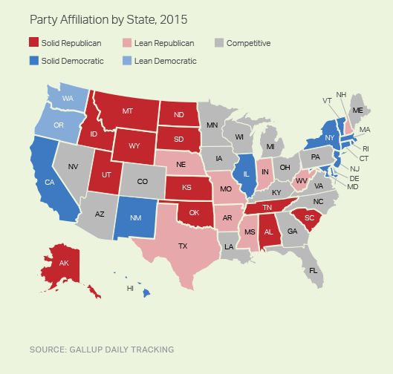
A map showing Republican-leaning states in red and Democratic-leaning states in blue. a.k.a. red and blue states map.
In 2008, 35 states leaned Democratic and this number is down to only 14 now. In the same time, the number of Republican leaning states rose from 5 to 20. Gallup determined 16 states to be competitive, i.e., they leaned toward neither party. Wyoming, Idaho and Utah were the most Republican states, while states that leaned the most Democratic were Vermont, Hawaii and Rhode Island.

Famous Republican vs Democratic Presidents
Republicans have controlled the White House for 28 of the last 43 years since Richard Nixon became president. Famous Democrat Presidents have been Franklin Roosevelt, who pioneered the New Deal in America and stood for 4 terms, John F. Kennedy, who presided over the Bay of Pigs invasion and the Cuban missile crisis, and was assassinated in Office; Bill Clinton, who was impeached by the House of Representatives; and Nobel Peace Prize winners Barack Obama and Jimmy Carter.
Famous Republican Presidents include Abraham Lincoln, who abolished slavery; Teddy Roosevelt, known for the Panama Canal; Ronald Reagan, credited for ending the Cold War with Gorbachev; and the two Bush family Presidents of recent times. Republican President Richard Nixon was forced to resign over the Watergate scandal.
To compare the two parties' presidential candidates in the 2016 elections, see Donald Trump vs Hillary Clinton.

Control of the White House
This graphic shows which party controlled the White House since 1901. You can find the list of Presidents on Wikipedia.
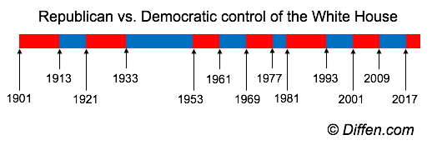
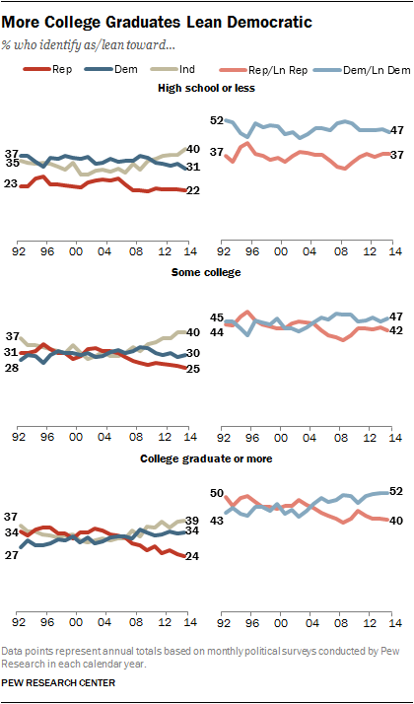
A timeline showing which political party had an incumbent in the White House. Republican presidents in red and Democratic presidents in blue. 1901-present.

Republican vs Democratic Demographics
The Pew Research Group, among others, regularly surveys American citizens to determine party affiliation or support for various demographic groups. Some of their latest results are below.

Partisan Advantages by Age
In general, support for the Democratic party is stronger among younger voters. As the demographic gets older, support for the Republican party rises.
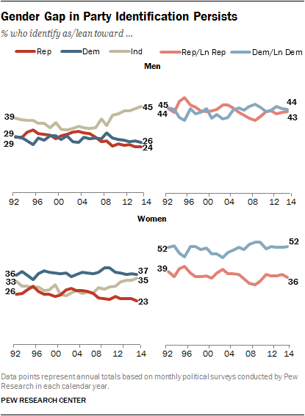
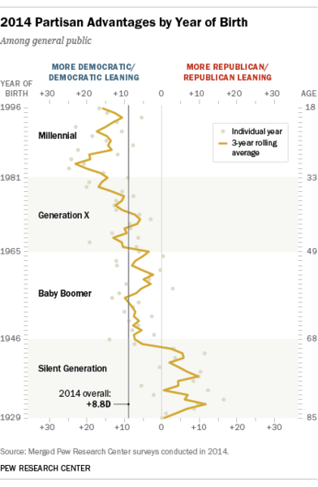
Partisanship advantage by year of birth, as of 2014 (published by Pew Research)

By Gender
In general, women lean Democratic while support among men is roughly evenly split between the two parties.

Gender gap in party identification (Pew Research Group, 2015)

By Race
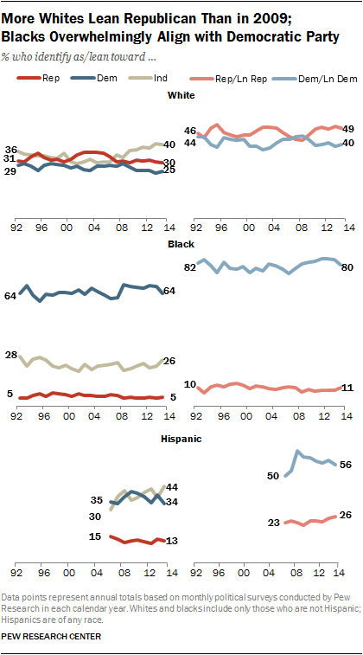
Support for parties can also vary significantly by ethnicity and race, with African-Americans and Hispanics. For example, in the 2012 presidential election, Republican Mitt Romney garnered only 6% of the black vote; and in 2008 John McCain got only 4%.^{[7]}

