Patrick Henry
Accomplishments:
- _____________
_________________
- _______________________________
Education: ________
_________________
Work/Jobs: _______
_________________
Thomas Jefferson
Accomplishments:
- _____________
_________________
- _______________________________
Work/Jobs: _______
_________________
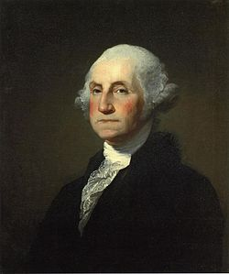
George Washington
Accomplishments:
1. _______________
__________________________________2.________________________________________________
Education: ________
_________________
Work/Jobs: _______
___________________________________________________
Founding Fathers Pamphlet

Featuring:
Benjamin Franklin
Alexander Hamilton
George Mason
James Madison
George Washington
Patrick Henry

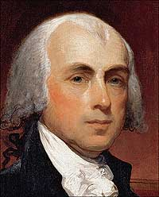
James Madison
Accomplishments:
- _____________
__________________________________
- ________________________________________________
Education: ________
_________________
Work/Jobs: _______
___________________________________________________
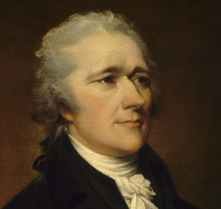
Alexander Hamilton
Accomplishments:
- _____________
__________________________________
- ________________________________________________
Education: ________
_________________
Work/Jobs: _______
___________________________________________________

Benjamin Franklin
Accomplishments:
- _____________
_________________
- _______________________________
Education: ________
_________________
Work/Jobs: _______
_________________
George Mason
Accomplishments:
- _____________
_________________
- _______________________________
Work/Jobs: _______
_________________

