Oregon Trail
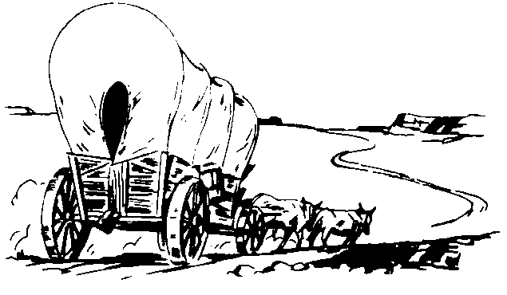
Excerpt from the Diary of Catherine Sager Pringle in 1844:
“Starting one the plains we waited several days at the Missouri River. Many friends came that far to see the emigrants start on their long journey, and there was much sadness at the parting, and a sorrowful company crossed the Missouri that bright spring morning. The motion of the wagon made us all sick, and it was weeks before we got used to the seasick motion. Rain came down and required us to tie down the wagon covers, and so increased our sickness by confining the air we breathed. Our cattle recrossed in the night and went back to their winter quarters. This caused delay in recovering them and a weary, forced march to rejoin the train. This was divided into companies, and we were in that commanded by William Shaw. Soon after starting Indians raided our camp one night and drove off a number of cattle. They were pursued, but never recovered….After Laramie we entered the great American desert, which was hard on the teams. Sickness became common. Father and the boys were all sick, and we were dependent for a driver on the Dutch doctor who set my leg. He offered his services and was employed, but though an excellent surgeon, he knew little about driving oxen. Some of them often had to rise from their sick beds to wade streams and get the oxen safely across. One day four buffalo ran between our wagon and the one behind. Though feeble, father seized his gun and gave chase to them. This imprudent act prostrated him again, and it soon became apparent that his days were numbered. He was fully conscious of the fact, but could not be reconciled to the thought of leaving his large and helpless family in such precarious circumstances. The evening before his death we crossed Green River and camped on the bank. Looking where I lay helpless, he said: "Poor child! What will become of you?" Captain Shaw found him weeping bitterly. He said his last hour had come, and his heart was filled with anguish for his family. His wife was ill, the children small, and one likely to be a cripple. They had no relatives near, and a long journey lay before them. In piteous tones he begged the Captain to take charge of them and see them through. This he stoutly promised. Father was buried the next day on the banks of Green River. His coffin was made of two troughs dug out of the body of a tree, but next year emigrants found his bleaching bones, as the Indians had disinterred the remains.”

- What did you learn about the Pioneers trip along the trail from reading the diary entries?
- What were the Pioneers encounters with the Native Americans like during their time on the trail?

