Missionaries

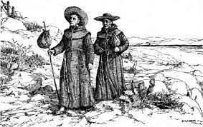

Missionaries had one goal on their mind: to convert Native Americans into Christian Indians. Lewis and Clark created good relations with the Nez Perce tribe on their expedition. In 1831, 3 men from the tribe come to St. Louis to learn the white ways of life. They become interested in learning about the Bible and requested that someone come west with them to teach them about the religion. Two couples, Marcus and Narcissa Whitman and Henry and Eliza Spalding set out on a mission West to teach the Bible and convert Native Americans. The task of converting Native Americans was a challenge in itself because of how little both groups of people knew about each other. The Spalding couple stayed with the Nez Perce tribe while the Whitman couple attempted to convert Native Americans from a tribe nearby, the Cayuse tribe. The Spaldings’ were successful and converted a few Native Americans to be Christian Indians, after spending a few years with the tribe. The Whitman couple didn’t convert anybody from the Cayuse tribe because this tribe was more interested in the white man’s weapons and tools as opposed to religion. The Whitmans’ focused on convincing others to move out West into Oregon. They started to guide groups of settlers on the Oregon Trail. As more and more settlers come to the West, Narccissa mentioned “The poor Indians are amazed at the overwhelming number of Americans coming.” Suddenly, many people started getting sick with the measles. Even though Marcus did what he could to help, whites were typically able to recover while the Native Americans did not. Marcus ends up getting accused for poisoning Native Americans on purpose and angry warriors kill him and his wife, Narcissa. Missionaries moved West hoping to convert as many Native Americans to Christian Indians as possible but the truth is that few Indians really did convert. What the missionaries did accomplish was open the West for settlement and encourage migration.

Pioneer Women

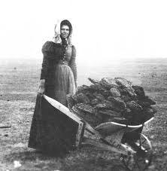

Many women moving west were moms and wives but plenty were also single looking for new opportunities or husbands. Traveling the Oregon Trail took 4-6 months and it covered 2,200 miles of land. On the trail, women were expected to do the same work they would normally do at home on top of traveling 15-25 miles a day. The women were responsible for cooking, washing clothes and taking care of the children. One woman shared her experience on the trail and said, “I would make a brave effort to be cheerful and patient until the camp work was done; then starting out ahead of the team and my men folks when I thought I had gone beyond hearing distance, I would throw myself down on unfriendly desert and give away like a child to sob and tears.” The hardships of the journey on the Oregon Trail were already enough emotionally for the women to deal with. On the journey, people died from accidents, drowning, diseases, freezing to death and dehydrating.
The African American women had to battle even a bigger challenge of being a woman and African American. Some African American women worried that even though slavery was outlawed in the West that someone might track them down or return them back to the Southern slave states. The women who moved west shaped the future of the region and created a new status for themselves. The women were responsible for setting up schools, libraries and churches. A woman named, Annie Bidwell taught Native American women how to sew and taught their children how to read and write in English. The women who lived out West had a sense of freedom and equality, which paved the way for more equal treatment of women throughout the whole rest of the country.

Mormons

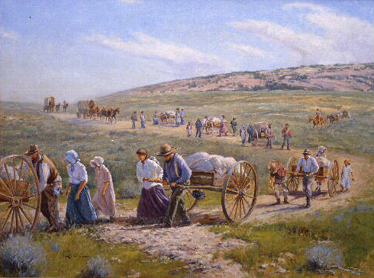

The Mormons were members of the Church of Jesus Christ of Latter Day Saints. Joseph Smith found the new church in New York in 1830. Smith taught that he had received a sacred book, The Book of Mormon from an angel. He believed it was his duty to create a community of believers who would serve God faithfully. No matter where this religious group settled, they were prosecuted everywhere they went – New York, Ohio, Missouri and Illinois. People were offended about their acceptance of polygamy (having more than one wife). Joseph Smith ended up getting killed by a mob in Illinois. The new leader Bringham Young took over as a leader for the Mormons and decided they would move to Utah. Young carefully planned this journey west to try to make it as least difficult as possible but it still was a challenging journey. One Mormon said, “ We soon thought it was unusual to leave a campground without burying one or more persons. Once they reached Utah, the Mormons began their first settlement in Salt Lake City. When Young died, Utah had 125,00 Mormons living in 500 settlements. Mormons had to learn new ways to farm in this dry region. They build canals dams and irrigation ditches to water their farms in the valley. The Mormons planted their faith firmly in Utah. The Mormon Church has grown into a worldwide religion with 7 million members with its center still being in Salt Lake City.

Forty-Niners

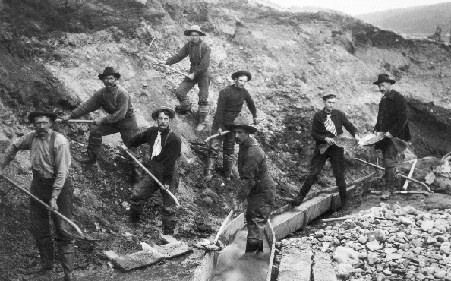

In 1848, carpenter James Marshall was building a sawmill on the American River in northern California. When he noticed something shiny he said, “I reached my hand down and picked it up.” When he saw what it was he said, “It made my heart thump for I felt certain it was gold.” When people heard about this discovery they dropped everything in order to go look for gold and a quick way to get rich. By 1849, thousands of gold seekers came to California. These people were known as the forty-niners and two thirds of them were American. The rest came from South America, Europe, Australia and China. The first challenge the forty-niners faced was how to actually get to California. Most of the forty-niners were young men. When a woman arrived to Sacramento with her family, one miner offered her $5 for a biscuit just so he can eat bread made by a woman. When she hesitated, he doubled his offer. The woman said, “Women wee so scarce in those days. I lived 6 months in Sacramento and saw only two.” The mining camps were filled with drinking saloons and gambling tables with no police to keep order. Miners spent long days doing tedious work looking for gold that many of them never even found. At the end of the gold rush when all the gold was essentially gone a miner confessed “there were thousands of men now in California who would gladly go home if they had the money.” The gold rush ended in 1852. The diseases that the forty niners brought to California with them killed off 120,000 Native Americans in about 20 years. Due to the Gold Rush, California was the first territory out West to become a state because they had a high enough population. California was transformed into a diverse land of economic opportunity.

Chinese

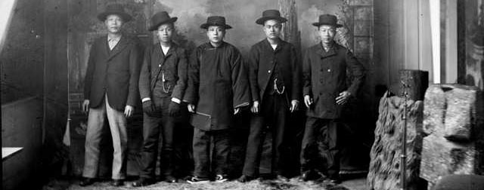

To the Chinese, California sounded like a paradise with plenty of money to go around. Thousands made the journey across the Pacific Ocean in search of a new life. As mining became more difficult, Americans started to resent the Chinese even more. American miners wanted the government to kick them out. The Chinese were not kicked out but a new policy required foreigners to pay monthly for a license to mine. This caused many foreigners to leave but not he Chinese. Americans then tried harassing the Chinese to leave by burning their shacks, beatings and bullying. Eventually many Chinese men did leave.
Discriminatory legislation forced many Chinese out of the gold fields and into low-paying, menial, and often arduous jobs. In many cases, they took on the most dangerous and least desirable components of work available. They worked on reclaiming marshes in the Central Valley so that the land could become agriculturally productive. They built the stone bridges and fences, and constructed roads. The most impressive construction feat of Chinese Americans was their work on the western section of the transcontinental railroad. Chinese-American workers laid much of the tracks for the Central Pacific Railroad through the foothills and over the high Sierra Nevada, much of which involved hazardous work with explosives to tunnel through the hills. Their speed, dexterity, and outright perseverance, often in brutally cold temperatures and heavy snow through two record breaking winters, is a testimony to their outstanding achievements and contributions to opening up the West. Other Chinese men started opening restaurants and laundries in California cities. One miner confessed that the Chinese restaurants were, “the best eating houses in San Francisco” So many Chinese settled in San Francisco that the neighborhood started to be called Chinatown and to this day remains the largest Chinese community in the United States. The Chinese work ethic did not go unnoticed. Many noticed that the Chinese worked hard, had a lot of skills and energy. Where the Chinese settled they brought with them a lot of diverse culture including arts, tastes, scents and sounds.
African Americans

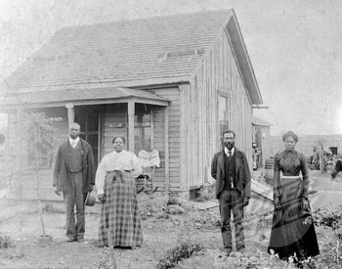

Though they rarely make it to the history books, black men and women helped shape the Old West. Hoping to find riches and freedom many African Americans headed west. By 1852, more than 2,000 African Americans lived in California. Some got wealthy in the mines but majority did not. There was still prejudice because even though California was a Union state it still denied African Americans the right to vote, kept them from testifying in court and prohibited integrated schools.
Life on the frontier was hard for everyone, but blacks often faced the extra burden of racism.
Black women had to work just as hard as black men to make their way out West. Mary Fields, born a slave in a log cabin in Tennessee, went west in 1884, when she was 52 years old. She ended up in Cascade, Montana, with the nuns for whom she worked. Fields was a towering figure on the Western frontier. She was "six feet tall, weighed more than 200 pounds, wore men's clothes, and puffed thick black cigars." A powerful woman made strong by years of heavy slave work, Fields refused to put up with ill treatment from anyone. She lost her job with the nuns when she got into a gunfight with another hired hand. But Fields was tough enough to make her own way on the frontier. She carried the U.S. mail, ran a restaurant, and drove a stagecoach, which earned her the nickname "Stagecoach Mary." In her old age, Fields ran a laundry. Even at age 70, she could hold her own: When a man tried to skip out without paying his laundry bill, Fields followed him, tapped on his shoulder, and when he turned around socked him on the jaw. He went down and Fields went back to work, declaring, "His bill's been paid in full."

