Introduction Outline:
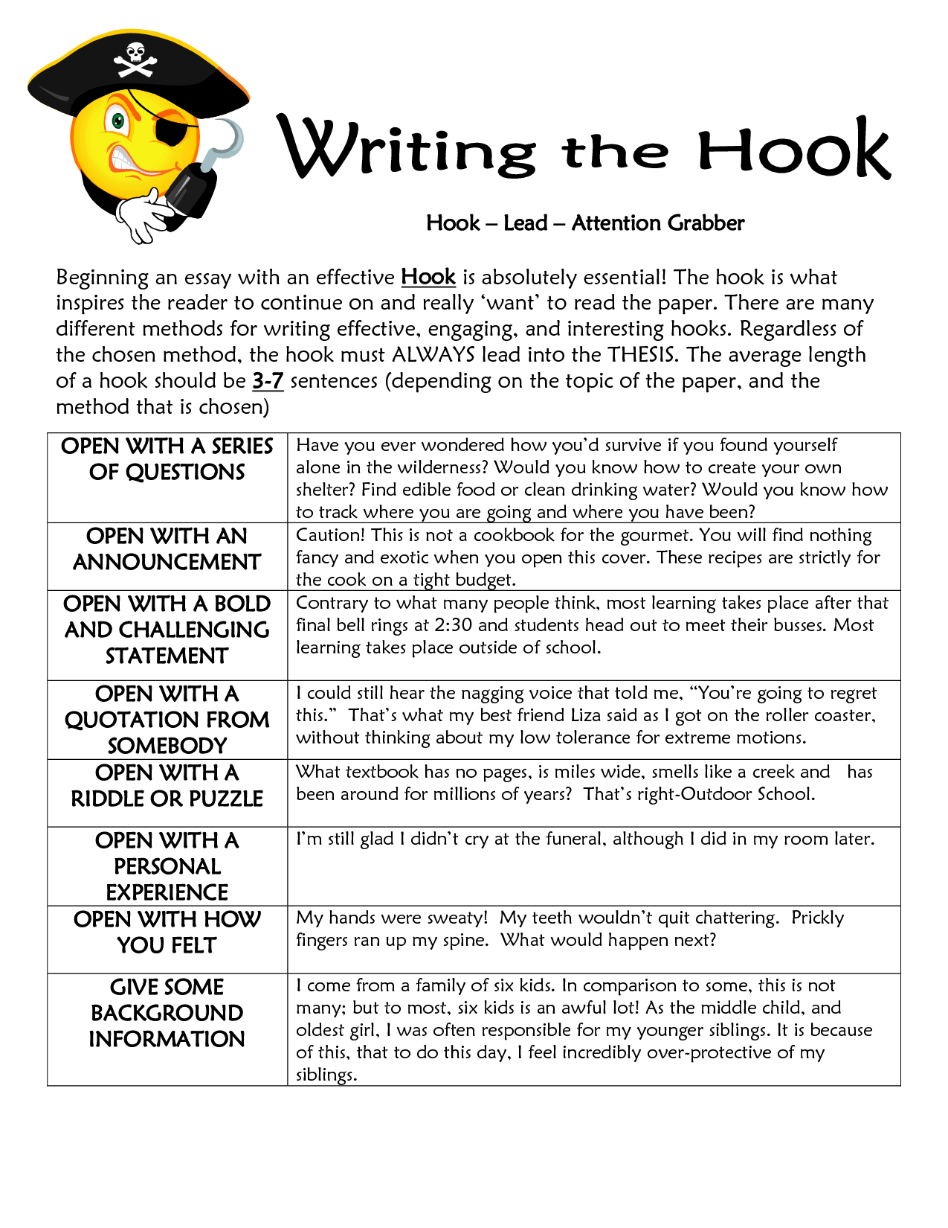
Step 1-Hook
Select a Hook that will entice readers to actually want to read your essay!
_________________________________________________________________________________________________________________________________________________________________________________________________________________________________________________________________________________________________________________________________________________________________________________________________________________________________________________________
Step 2: Broad Introduction to the topic
Give us the basic background information on the issue. Be sure to be specific about what issue you are talking about. Zoos, Aquariums, captivity, conservation, etc.
________________________________________________________________________________________________________________________________________________________________________________________________________________________________________________________________________________________________________________________________________________________________________________________________________
Step 3: Write your thesis statement:
EX. ____________________ is _________________ because of _______________, ___________, and ____________. ________________________________________________________________________________________________________________________________________________________________________________________________________________________________________________________________________________________________________________________________________________________________________________________________

Addressing the Opposing Point of View
You have to show that you understand the other side of the issue and then redress the issue by responding directly to it. You can do this in anywhere BUT the conclusion. Which paragraph will you put this in_________________.
Step 1: What is the opposing point of view? Give a specific fact/piece of evidence.
________________________________________________________________________________________________________________________________________________________________________________________________________________________________________________________________________________________________________________________________________________________________________________________________________
Step 2: Respond to the opposing point of view using specific evidence that matches what they say. For instance if the opposing side says that animals should be left in the wild because they can live longer, you might respond with “they have the opportunity in some cases to live longer, but like in the case of the Black Rhino poaching can cause their extinction even with protections.”
________________________________________________________________________________________________________________________________________________________________________________________________________________________________________________________________________________________________________________________________________________________________________________________________________
Conclusion Outline:
Your conclusion is meant to wrap up and summarize your claim. Your reader shouldn’t get any new information here, and should feel like you are taking all the loose ends and bringing them together. Make sure they leave agreeing with your argument!
Step 1: Transition back into your topic and claim. This is a connecting thought that attaches the last body paragraph back to the big idea.
________________________________________________________________________________________________________________________________________________________________________________________________________________________________________________________________________________________________________________________________________________________________________________________________________
Step 2: Restate your thesis in a new way. It can be done in a few sentences, BUT you must comment on you topic, claim, and the evidence you have given the reader.
________________________________________________________________________________________________________________________________________________________________________________________________________________________________________________________________________________________________________________________________________________________________________________________________________
Step 3: Final thought. You want to leave your reader with something that is poignant. Poignant means that it leaves an impression on the reader and seems really smart. What final thought or feeling do you want them to walk away with?
________________________________________________________________________________________________________________________________________________________________________________________________________________________________________________________________________________________________________________________________________________________________________________________________________

